实验题目：lab0，操作系统的编程基础

实验环境

<http://www.shiyanlou.com/courses/221>

安装linux环境，并安装gcc和gdb。

1. 了解汇编

尝试理解下面的命令

$gcc -S -m32 lab0_ex1.c

接着我们将得到lab0_ex1.s文件，请写出汇编代码与c代码之间的关系。

**汇编语言用栈 寄存器 来执行c代码**

**cld \n\t"*//将标志寄存器Flag的方向标志位DF清零。***

**"rep \n\t"*//重复前缀指令***

**"stosl"*//将EAX中的值保存到ES:EDI指向的地址中***

1. 用gdb调试

尝试下面的命令，

$gcc -g -m32 lab0_ex2.c

接着我们会得到a.out文件，请用gdb调试，并写出设置断点、单步执行及查看变量的过程。

**调试**

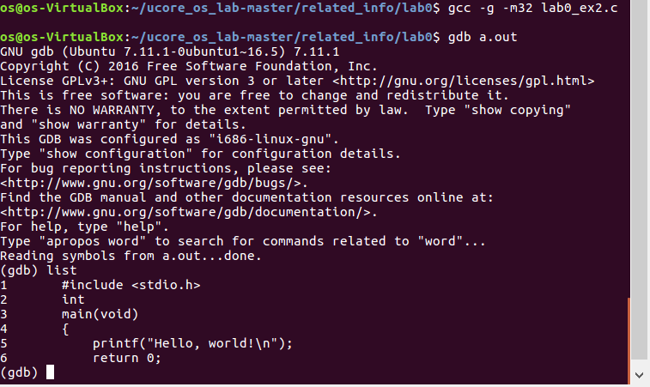

设置断点 并逐条运行（没有变量）

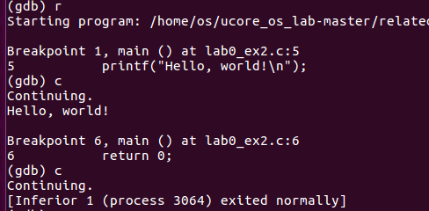

1. 掌握指针和类型转换相关的Ｃ编程

分析如下代码段，

#include <stdio.h>

#define STS_IG32 0xE // 32-bit Interrupt Gate

#define STS_TG32 0xF // 32-bit Trap Gate

typedef unsigned uint32_t;

#define SETGATE(gate, istrap, sel, off, dpl) { \

(gate).gd_off_15_0 = (uint32_t)(off) & 0xffff; \

(gate).gd_ss = (sel); \

(gate).gd_args = 0; \

(gate).gd_rsv1 = 0; \

(gate).gd_type = (istrap) ? STS_TG32 : STS_IG32; \

(gate).gd_s = 0; \

(gate).gd_dpl = (dpl); \

(gate).gd_p = 1; \

(gate).gd_off_31_16 = (uint32_t)(off) >> 16; \

}

/* Gate descriptors for interrupts and traps */

struct gatedesc {

unsigned gd_off_15_0 : 16; // low 16 bits of offset in segment

unsigned gd_ss : 16; // segment selector

unsigned gd_args : 5; // # args, 0 for interrupt/trap gates

unsigned gd_rsv1 : 3; // reserved(should be zero I guess)

unsigned gd_type : 4; // type(STS_{TG,IG32,TG32})

unsigned gd_s : 1; // must be 0 (system)

unsigned gd_dpl : 2; // descriptor(meaning new) privilege level

unsigned gd_p : 1; // Present

unsigned gd_off_31_16 : 16; // high bits of offset in segment

};

int

main(void)

{

unsigned before;

unsigned intr;

unsigned after;

struct gatedesc gintr;

intr=8;

before=after=0;

gintr=*((struct gatedesc *)&intr);

SETGATE(gintr, 0,1,2,3);

intr=*(unsigned *)&(gintr);

printf("intr is 0x%x\n",intr);

printf("intr is 0x%llx\n", gintr);

return 0;

}

写出gintr和intr的结果，试着编译这段代码，如果遇到错误进行改正，并分析错误原因。

**结果**

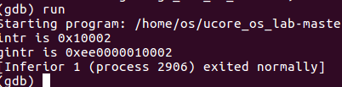

**错误**

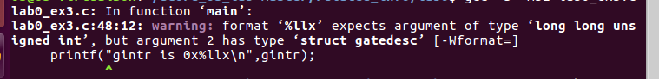

**改进**

**printf("gintr is 0x%llx\n",*(unsigned long long *)&(gintr));**

**然后就不会有错误提示了**

**因为是 longlong型的 所以找到gintr地址 转成指向ll型指针 就可以了**

**或者修改 0x%11x 应该也行**

4. 掌握通用链表结构相关的Ｃ编程

查看list.h和lab0_ex4.c，编写一个程序，利用list.h中的链表结构，将26个英文字母存入链表中，并逆序打印出来。

#include <stdio.h>

#include <stdlib.h>

#include "defs.h"

struct list_entry {

struct list_entry *prev, *next;

};

typedef struct list_entry list_entry_t;

struct entry {

list_entry_t node;

int num;

};

int main() {

struct entry head;

list_entry_t* p = &head.node;

list_init(p);

head.num = 0;

int i;

for (i = 1; i != 26; i ++) {

struct entry * e = (struct entry *)malloc(sizeof(struct entry));

e->num = i;

list_add(p, &(e->node));

p = list_next(p);

}

//reverse list all node

printf("%d\n",((struct entry *)p)->num);

while ((p = list_prev(p)) != &head.node)

printf("%d\n", ((struct entry *)p)->num);

return 0;

}

#ifndef __LIBS_LIST_H__

#define __LIBS_LIST_H__

#ifndef __ASSEMBLER__

#include "defs.h"

/* *

* Simple doubly linked list implementation.

*

* Some of the internal functions ("__xxx") are useful when manipulating

* whole lists rather than single entries, as sometimes we already know

* the next/prev entries and we can generate better code by using them

* directly rather than using the generic single-entry routines.

* */

struct list_entry {

struct list_entry *prev, *next;

};

typedef struct list_entry list_entry_t;

static inline void list_init(list_entry_t *elm) __attribute__((always_inline));

static inline void list_add(list_entry_t *listelm, list_entry_t *elm) __attribute__((always_inline));

static inline void list_add_before(list_entry_t *listelm, list_entry_t *elm) __attribute__((always_inline));

static inline void list_add_after(list_entry_t *listelm, list_entry_t *elm) __attribute__((always_inline));

static inline void list_del(list_entry_t *listelm) __attribute__((always_inline));

static inline void list_del_init(list_entry_t *listelm) __attribute__((always_inline));

static inline bool list_empty(list_entry_t *list) __attribute__((always_inline));

static inline list_entry_t *list_next(list_entry_t *listelm) __attribute__((always_inline));

static inline list_entry_t *list_prev(list_entry_t *listelm) __attribute__((always_inline));

static inline void __list_add(list_entry_t *elm, list_entry_t *prev, list_entry_t *next) __attribute__((always_inline));

static inline void __list_del(list_entry_t *prev, list_entry_t *next) __attribute__((always_inline));

/* *

* list_init - initialize a new entry

* @elm: new entry to be initialized

* */

static inline void

list_init(list_entry_t *elm) {

elm->prev = elm->next = elm;

}

/* *

* list_add - add a new entry

* @listelm: list head to add after

* @elm: new entry to be added

*

* Insert the new element @elm *after* the element @listelm which

* is already in the list.

* */

static inline void

list_add(list_entry_t *listelm, list_entry_t *elm) {

list_add_after(listelm, elm);

}

/* *

* list_add_before - add a new entry

* @listelm: list head to add before

* @elm: new entry to be added

*

* Insert the new element @elm *before* the element @listelm which

* is already in the list.

* */

static inline void

list_add_before(list_entry_t *listelm, list_entry_t *elm) {

__list_add(elm, listelm->prev, listelm);

}

/* *

* list_add_after - add a new entry

* @listelm: list head to add after

* @elm: new entry to be added

*

* Insert the new element @elm *after* the element @listelm which

* is already in the list.

* */

static inline void

list_add_after(list_entry_t *listelm, list_entry_t *elm) {

__list_add(elm, listelm, listelm->next);

}

/* *

* list_del - deletes entry from list

* @listelm: the element to delete from the list

*

* Note: list_empty() on @listelm does not return true after this, the entry is

* in an undefined state.

* */

static inline void

list_del(list_entry_t *listelm) {

__list_del(listelm->prev, listelm->next);

}

/* *

* list_del_init - deletes entry from list and reinitialize it.

* @listelm: the element to delete from the list.

*

* Note: list_empty() on @listelm returns true after this.

* */

static inline void

list_del_init(list_entry_t *listelm) {

list_del(listelm);

list_init(listelm);

}

/* *

* list_empty - tests whether a list is empty

* @list: the list to test.

* */

static inline bool

list_empty(list_entry_t *list) {

return list->next == list;

}

/* *

* list_next - get the next entry

* @listelm: the list head

**/

static inline list_entry_t *

list_next(list_entry_t *listelm) {

return listelm->next;

}

/* *

* list_prev - get the previous entry

* @listelm: the list head

**/

static inline list_entry_t *

list_prev(list_entry_t *listelm) {

return listelm->prev;

}

/* *

* Insert a new entry between two known consecutive entries.

*

* This is only for internal list manipulation where we know

* the prev/next entries already!

* */

static inline void

__list_add(list_entry_t *elm, list_entry_t *prev, list_entry_t *next) {

prev->next = next->prev = elm;

elm->next = next;

elm->prev = prev;

}

/* *

* Delete a list entry by making the prev/next entries point to each other.

*

* This is only for internal list manipulation where we know

* the prev/next entries already!

* */

static inline void

__list_del(list_entry_t *prev, list_entry_t *next) {

prev->next = next;

next->prev = prev;

}

#endif /* !__ASSEMBLER__ */

#endif /* !__LIBS_LIST_H__ */